Co-sponsored by NADOHE and CDIHE

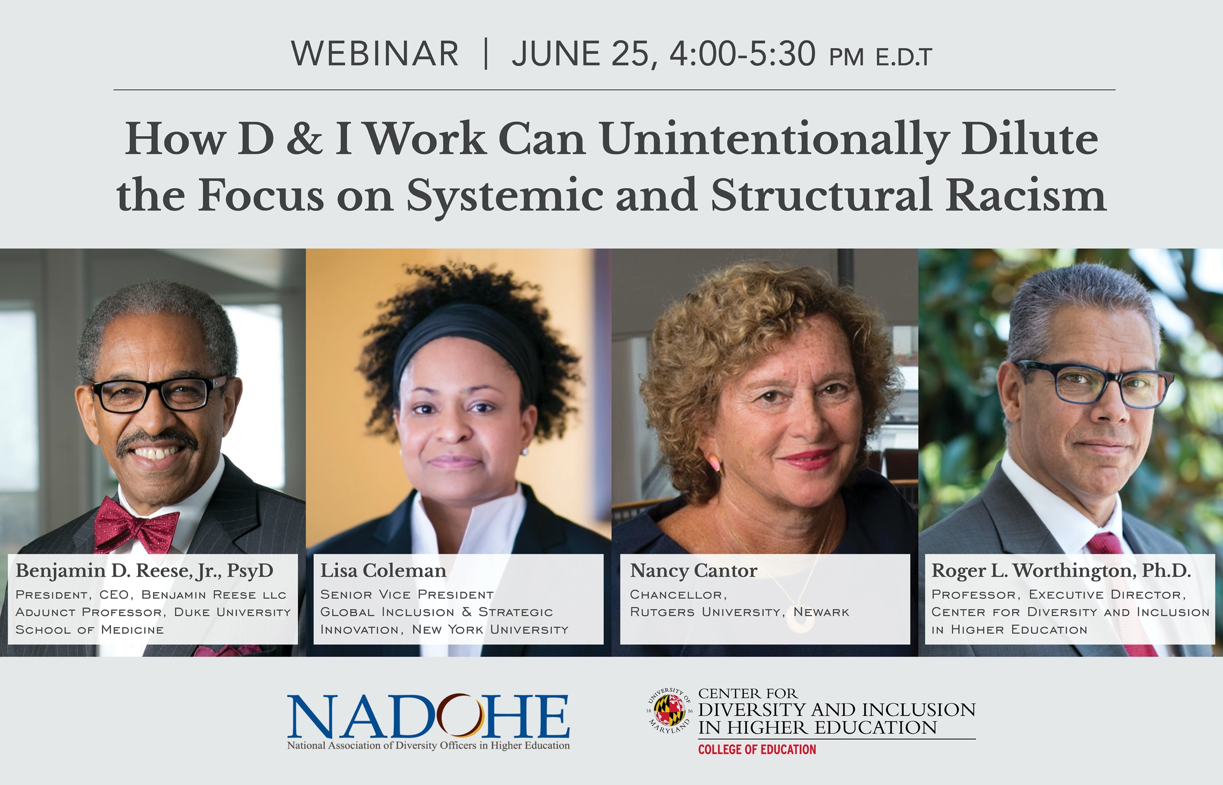

Higher education institutions are microcosms of the larger systemic racism reflected in U.S. society and commonly reproduce social inequalities. Diversity and inclusion efforts in institutions of higher education, in the absence of systematic antiracism efforts, sometimes operate to marginalize people of color and those from other oppressed groups, perpetuating longstanding practices that arise from and reproduce a modern form of racial and cultural colonization. Thus, it is essential that colleges and universities become aware of how they reify and reflect racism in the broader context (George Mwangi, Thelamour, Ezeofor, and Carpenter, 2018). Higher education institutions should act to eradicate racism embedded in institutional policies, procedures, practices, and everyday operations. This panel of nationally acclaimed experts will explore the crisis of racial violence in the United States, with emphasis on how higher education institutions and leaders must shift from a performative stance focused on diversity and inclusion to an intentional, active stance toward antiracism.
Program Objectives:

- To understand the differences between common conceptions of diversity, inclusion, and antiracism.
- To explore strategies for dismantling racist structures and systems in higher education.
- To examine the roles of leaders and professionals in higher education to advance antiracism initiatives on college and university campuses.

