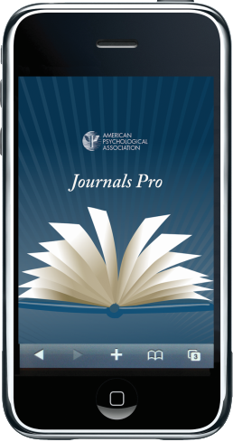

Reading the latest [***Journal of Diversity in Higher Education***](http://www.apa.org/pubs/journals/dhe/) articles on the go

is now as easy as…

1. Set up a free account at <https://my.apa.org> using the email address you provided for your National Association of Diversity Officers in Higher Education (NADOHE) membership as your user ID.
2. Download the APA Journals Pro app for [iPhone or iPad](http://on.apa.org/T5yhuB) or [Android](http://on.apa.org/ZXNKPB).
3. Open the App on your device and click the “Login” button on the bottom of the screen. Use your login information from Step 1.

Enjoy full-text access to all *Journal of Diversity in Higher Education* articles going back to Volume 1, Issue 1. You will also have abstract level access to over 80 psychology journals published by the American Psychological Association.

To access the journal electronically from your desktop computer, log into your account from step 1 (<https://my.apa.org>), scroll down to the “Subscriptions” box, and click *Journal of Diversity in Higher Education* under the Journals sub-header. You will be able to access the articles in full text either as pdf documents, or in html.

**Visit** [**http://www.nadohe.org/**](http://www.nadohe.org/) **for information on how to join NADOHE and receive *Journal of Diversity in Higher Education* as a member benefit.** Members also have electronic access to the journal through <https://my.apa.org> on the landing page after log in.

For more information about *Journal of Diversity in Higher Education,* including how to submit your manuscript for consideration, see <http://www.apa.org/pubs/journals/dhe>